**Analysis – 3**

**The memory usage of the data is around 6.1 mb.How can we reduce the memory usage of the data set?**

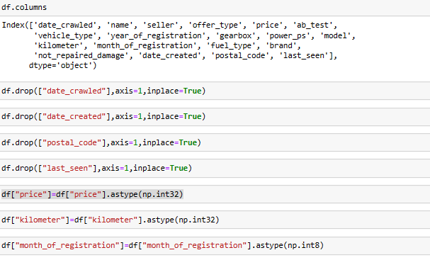

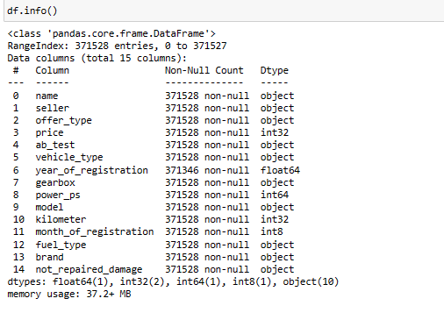

Here we are removing several columns from the "df" dataset using the `drop()` function with the `inplace=True` parameter. The columns being dropped are "num_of_Pictures", "date_crawled", "date_created", "postal_code", and "last_seen".

Then we are changing the data types of the "price", "kilometer", and "month_of_registration" columns using `astype()` from the NumPy library. We are converting "price" and "kilometer" to `np.int32` and " month_of_registration " to `np.int8`. This helps optimize memory usage and ensures the data is stored in the appropriate format.

Finally, checking the dataset's information with `df.info()` to get an overview of its structure.

# What is the Average price of vehicle by fuel type and gearbox type.Give a plot

# 

# 

# The bar chart shows the average power of vehicles grouped by vehicle type and gearbox type.

# The bar graph also shows that vehicles with automatic gearboxes have higher average power than vehicles with manual gearboxes.

**What is the Average power of a vehicle by vehicle type and gearbox type.Give a plot.**

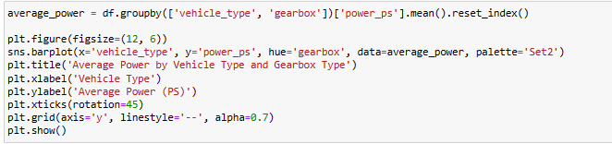

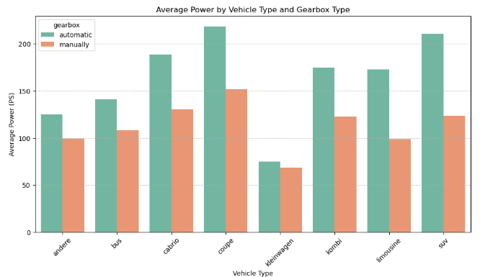

* The graph shows that the average power of vehicles with automatic transmissions is higher than that of vehicles with manual transmissions for all vehicle types**.**
* Overall, the graph shows that automatic transmissions offer a number of advantages over manual transmissions, including increased power, efficiency, and performance. However, automatic transmissions are also more complex and expensive than manual transmissions.

# What is the Average price of a vehicle by brand as well as vehicle type.Use heatmap to explain this.

# 

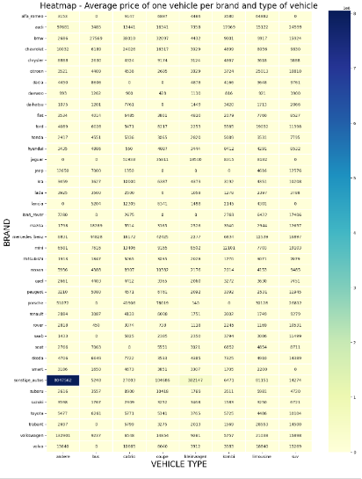

* The heatmap shows the average price of a vehicle per brand and type of vehicle. The darker the color of a cell in the heatmap, the higher the average price.
* The average price of a vehicle increases with the size and power of the vehicle.